Lab#03
Construct of Escape sequence, variables, various data types and in
java.
Objective
To get familiarity with the escape sequence, variables and various data types in java.
Lab Goals
To provide working insight into the usage of various java programming tools:
a. Demonstrate the working of class.
b. Understand escape sequences (\n, \t, \", \\, etc.) in Java for manipulating output.
c. Learn naming conventions for identifiers in Java.
d. Declare and initialize variables of different data types.
e. Understand numerical data types (int, long, short, byte) and their ranges.
f. Explore floating-point data types (float, double) and their precision.
g. Understand character, string, and Boolean data types in Java.
CLASS
A class is a user defined blueprint or prototype from which objects are created. It represents the set of properties or methods that are common to all objects of one.
Create java class
You can use the New Java Class wizard to create a Java class. The Java Class wizard can be invoked in different ways −
• By clicking on the File menu and selecting New → Class.
• By right clicking in the package explorer and selecting New → Class.
• By clicking on the class drop down button ( ) and selecting class ( ).
Before bringing up the New Java Class wizard, if possible, select the package in which the class is to be created so that the wizard can automatically fill in the package name for you.
USING THE NEW JAVA CLASS WIZARD
Once the java class wizard comes up −
• Ensure the source folder and package are correct.
• Enter the class name.
• Select the appropriate class modifier.
• Enter the super class name or click on the Browse button to search for an existing class.
• Click on the Add button to select the interfaces implemented by this class.
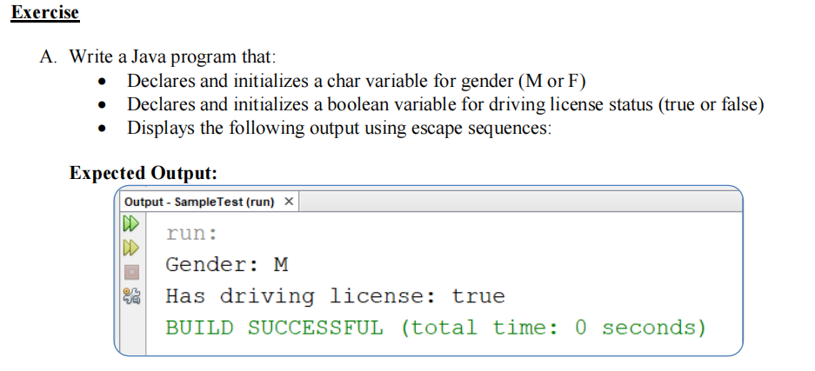
Program:
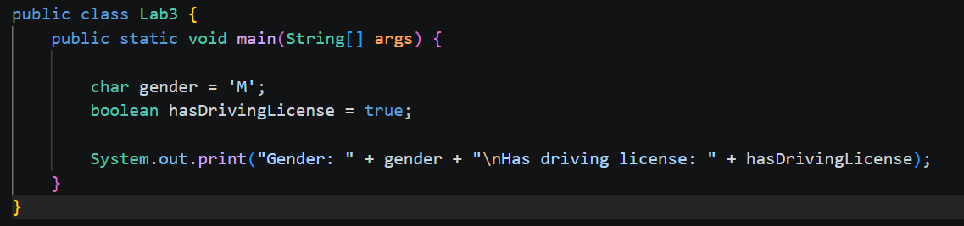
Output:
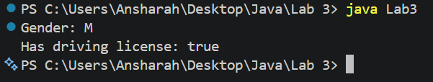
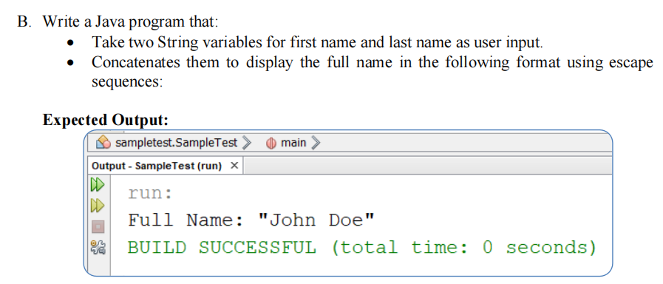

Program:
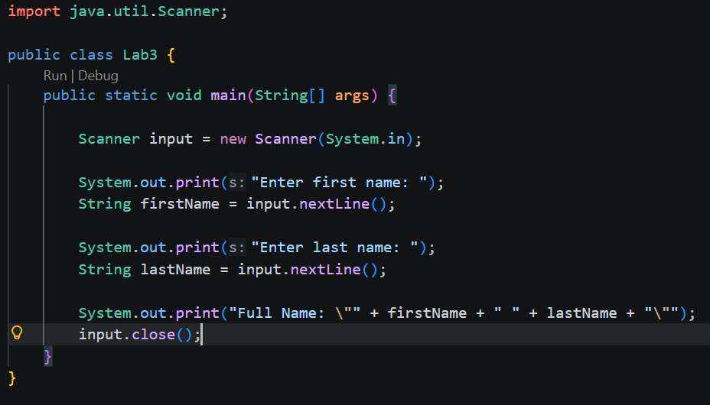
Output:
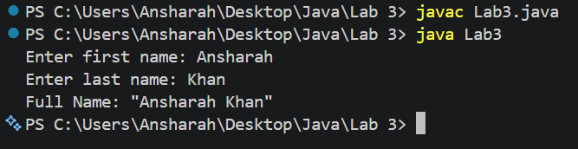
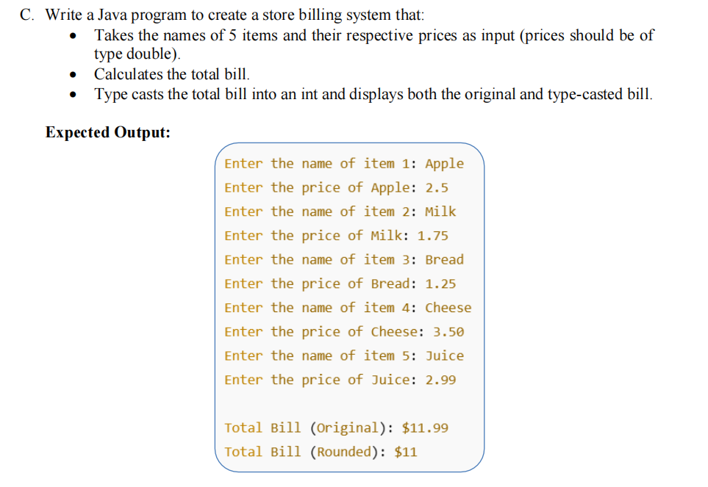

Program:
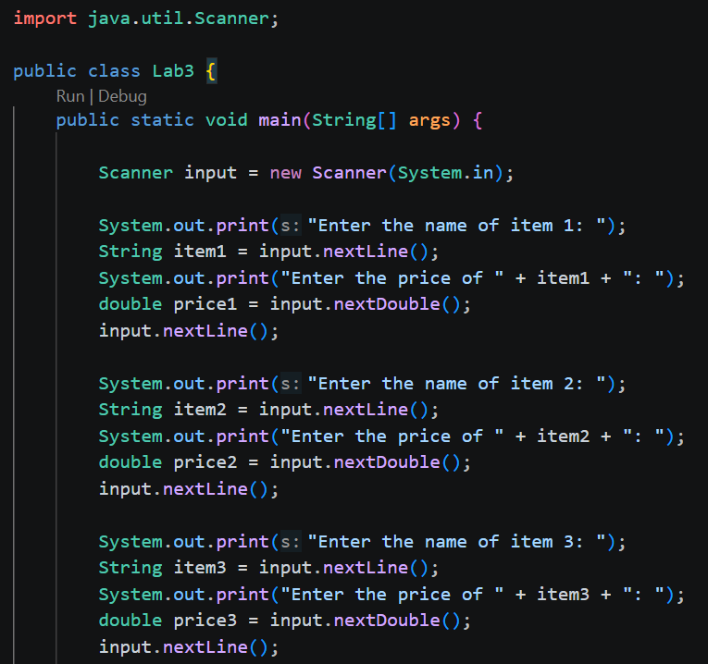
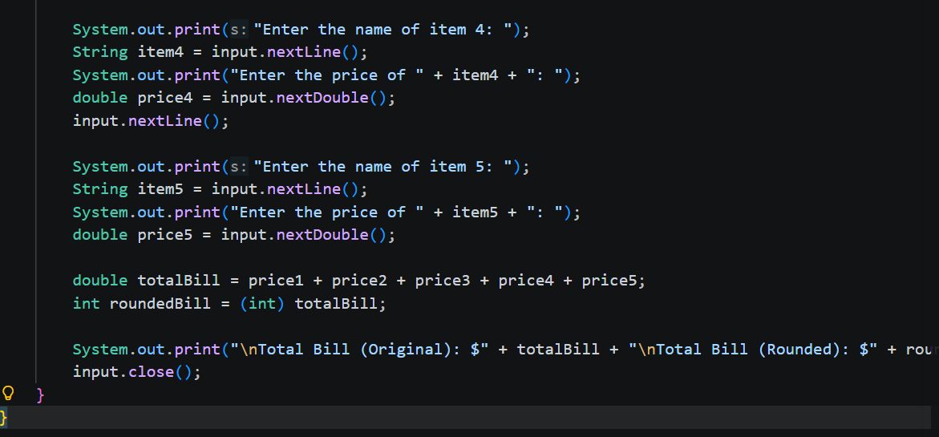
Output:
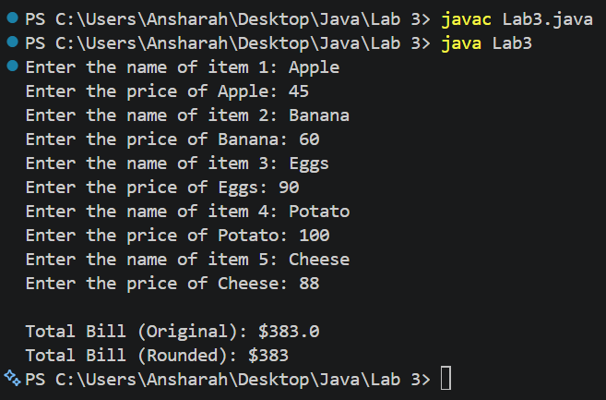

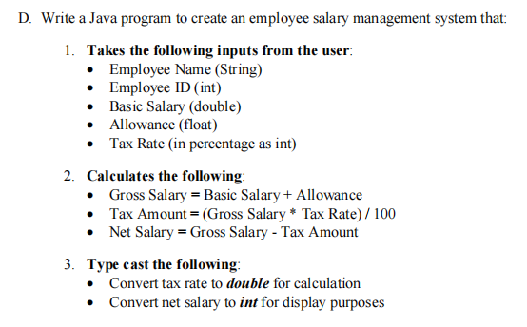
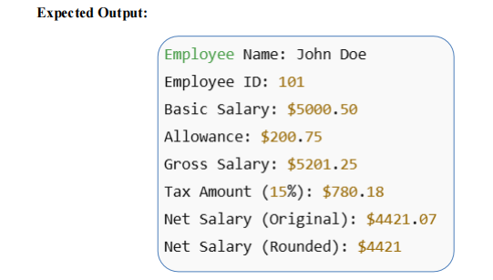
Program:
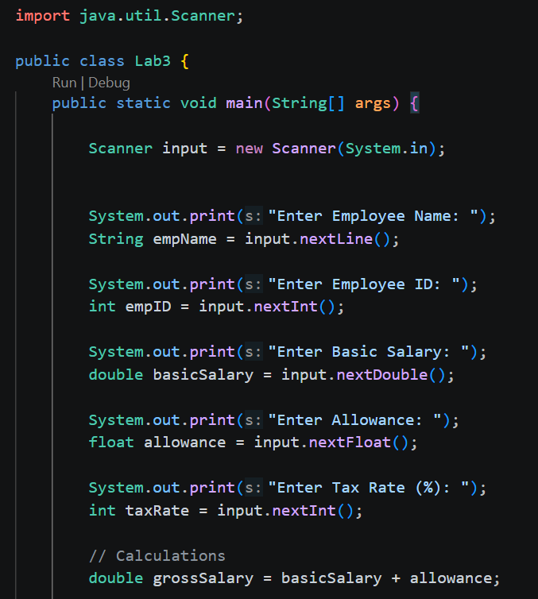

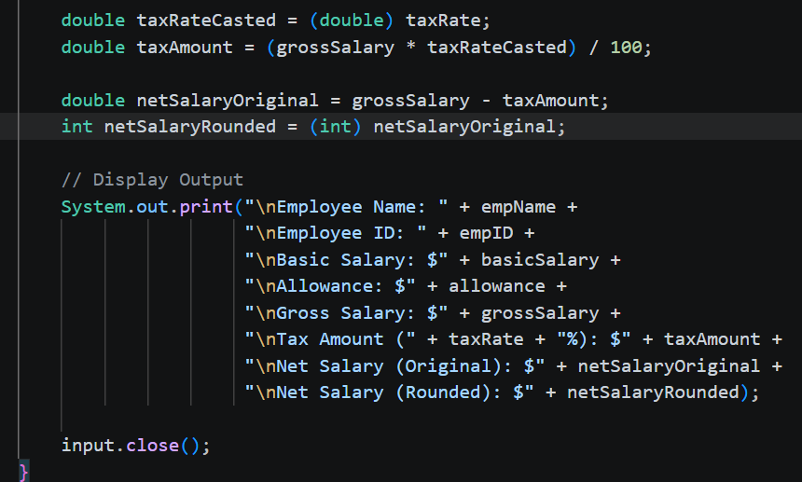
Output:
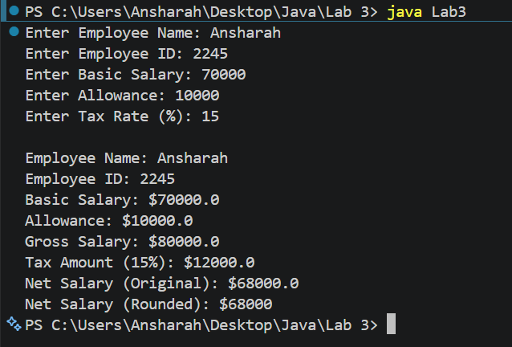
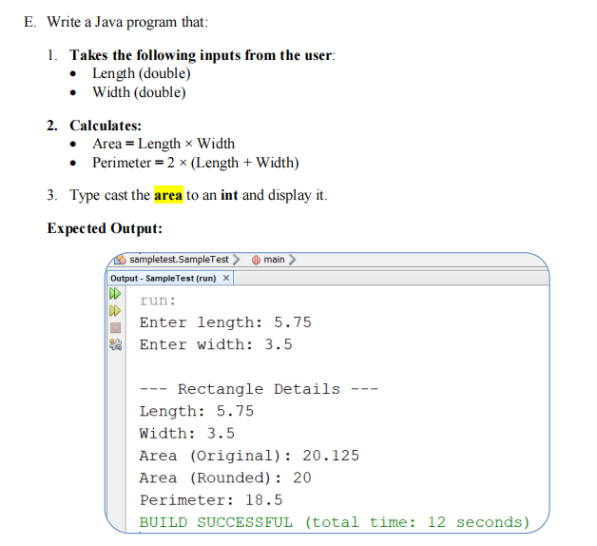
Program:
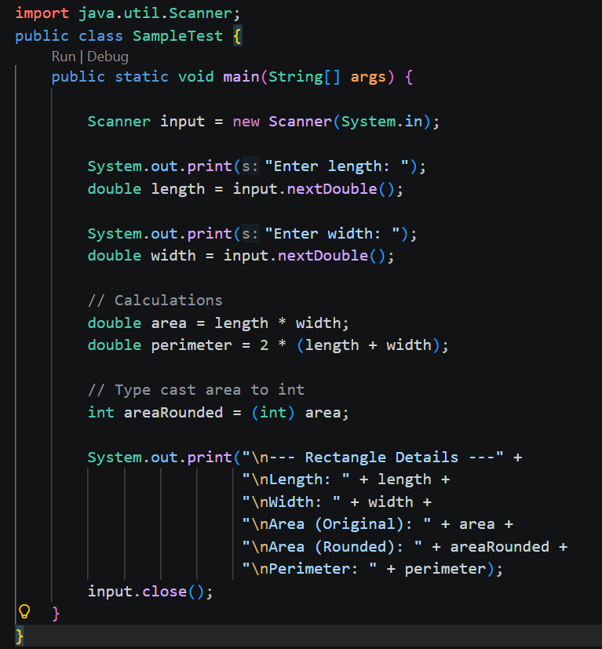
Output:
